SPH3U0 ELECTROMAGNETISM ACTIVITIES DATE:____________

Learning Goals: To understand that moving electric charges (electric current) generate an associated magnetic field.

Activity A: Materials: Large 6 V battery, copper wire and compass
Connect one end of the wire to one of the battery terminals. Place the compass below the wire
and briefly touch the other end of the wire to the other battery terminal. This is a short circuit so only keep the wire in contact with the terminal for a few seconds! Observe the response of the compass. Indicate the direction of the conventional current and the compass direction:

Repeat this activity with the compass placed above the wire. What do you notice?

Activity B:
Can you visualize the magnetic field around a straight wire? Briefly connect one or two batteries to the wire device and use a compass to verify there is a magnetic field around the wire. Investigate the field using the compass around the horizontal and vertical portions of the wire.
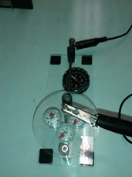
Observations with compass above and below horizontal wire:

Observations with compass beside the vertical wire:

Activity C:
Turn a coil into a magnet! Briefly connect one or two batteries to a coil and use a compass to verify that it has become magnetized. Try to draw the magnetic field pattern in the space provided. Can you identify the North and South pole?
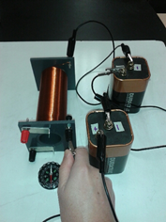
Magnetic field Pattern:

Activity D: Magnetic Field Patterns around Current-Carrying Devices
- Magnetic Field around a Current-Carrying Coil (Solenoid)

Observations: Observations:.
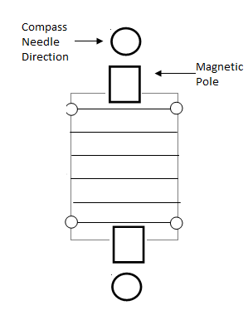
Indicate the current and compass directions. Switch the battery connections & repeat

Discussion: Do your observations match the RHR #2 predictions?

Activity E: Indicate the conventional current direction in the wire. Then indicate the compass needle deflection.
Direction of compass needle when it is placed below and
above the wire
Observations for horizontal wire:

Direction of compass needle when it is placed below and
above the wire
Switch the battery connections and repeat:

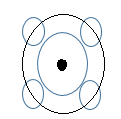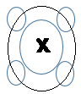Observations for the vertical wire: Draw in the compass directions when they are placed around the wire. A DOT means the current is coming up (towards you). A CROSS means the current is going down (away from you).

Discussion: Did the observations match the RHR #1 predictions?

•Activity C: Induction

Needle deflection when magnet North end moves into coil:

Needle deflection when magnet North moves out of coil:

Activity B: Motor Effect and Electromagnetic Induction
i) Motor Effect
• Connect the DC terminals of the power supply to the wires connected to the suspended copper
wire.
• Mark the North (N) and South (S) poles of the magnet on the diagram below and indicate the
direction of the magnetic field lines. Also indicate the direction of current in the wire cross-
section (i.e., is the current flowing towards you (•) or away from you (X)).
• Use the Right Hand Rule #3 to predict the direction of magnetic force on the wire. Indicate this
with a FORCE arrow on your diagram.
• Turn on the current and observe the direction of motion of the copper wire. Does it swing in
towards the magnet or away from the magnet?
• Compare the motion with the predicted motion. Do they agree?
• Repeat the procedure after changing either the magnet orientation or the connections on the
power supply.

Wire moved (in or out) _____________

ii) Electromagnetic Induction
• Attach the wires connected to the coil to the galvanometer (a device similar to an ammeter).
• Move the bar magnet in and out of the VERY QUICKLY. Observe the needle of the
galvanometer very closely to see if you have generated any current.
• If you can detect current, record the needle deflection when you move the magnet into the coil
compared to pulling the magnet out of the coil .
• See how much current is generated when you move the magnet SLOWLY versus QUICKLY in
and out of the coil.

•Observations:
Needle deflection when magnet moves into coil:

Needle deflection when magnet moves out of coil:

Comparison of current generated when magnet is moved slowly versus quickly:

_____________________________________________________________________________

